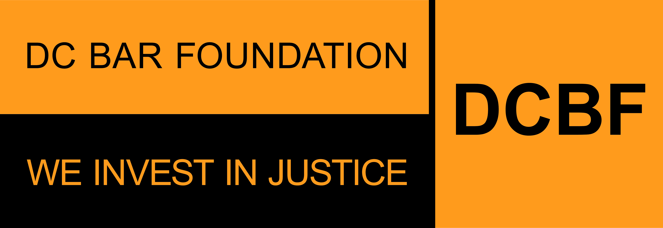
655 New York Ave., NW, 6th Floor P | 202-467-3750
Washington, DC 20001 www.dcbarfoundation.org F | 202-467-3753

YOUNG LAWYERS NETWORK LEADERSHIP COUNCIL
Guidelines and Membership Criteria

Composition:
The Young Lawyers Network Leadership Council (YLN LC) shall consist of up to 35 members. It shall elect its officers, including a chair (or co-chairs) and up to three liaisons to the DC Bar Foundation Board of Directors.

Term:
The Board of Directors appoints YLN LC members to two-year, renewable terms. The term year begins on October 1; however, appointment and service may start at any time. Typically, vacancies are filled each fall through a competitive application process.

Eligibility/Qualifications:
Members of the DC Bar in good standing are eligible to serve on the YLN LC. Members must be under the age of 40 at the start of their term, either live or work in the District of Columbia and commit to carrying out the group's responsibilities. The Foundation gives preference to attorneys with the following qualifications:

- A demonstrated commitment to access to justice issues, particularly with experience supporting the District's public interest and legal aid communities.

- A demonstrated interest and ability to raise money in support of civil legal aid programs.

- Attorneys who add to the diversity of expertise, skills, experience, and personal backgrounds of the YLN LC.
Note: Staff of LRAP (Loan Repayment Assistance Program)-eligible employers or organizations eligible to receive funding from the DC Bar Foundation are ineligible for membership in the Young Lawyers Network Leadership Council.

Duties:
Members of the YLN LC serve as ambassadors to young attorneys in the community to promote the Bar Foundation's mission and help raise additional resources supporting local legal aid programs.
Attendance/Participation: YLN LC members are expected to participate in quarterly meetings (as scheduled by the group's leadership). The Bar Foundation expects the YLN LC to create opportunities to engage younger lawyers in activities that raise awareness of and support the Foundation's role in strengthening the system of legal aid for people living in poverty and vulnerable situations or who are otherwise underserved in DC. Members are appointed to various Foundation Committees essential to the organization's operations and programs.

Site Visits: YLN LC members are invited to participate in site visits to current and prospective grantees. Site visits offer an unparalleled opportunity to see first-hand the Bar Foundation's impact on the delivery of civil legal aid to the DC community.

Note: The return of in-person site visits in 2021 and 2022 will depend on CDC health and safety guidelines. DCBF will keep all YLN LC members updated on these matters as they evolve.

Programs Support: YLN LC members will have the opportunity to actively assist with the Foundation's programmatic work by sitting on Board committees and participating in annual fundraising and public awareness events.

Note: The return of in-person fundraising and public awareness events in 2021 and 2022 will depend on CDC health and safety guidelines. DCBF will keep all YLN LC members updated on these matters as they evolve.

Financial Support: YLN LC members should be prepared to help secure financial support from their law firms or companies. Members should also be prepared to help secure financial support from other law firms, corporations, foundations, and individuals, in consultation with Bar Foundation staff. Lastly, YLN LC members are expected to make an annual personally significant" gift to the Foundation.

To Apply:
Interested applicants should email a completed application form, résumé, letter of interest, and up to two letters of support to Greer Richey, Development and Communications Specialist, at richey@dcbarfoundation.org. Please include Young Lawyers Network Leadership Council - [Your Full Name]" in the subject line of the email.

More Information:
Contact Greer Richey, Development and Communications Specialist, at richey@dcbarfoundation.org or (202) 853-9022, or visit www.dcbarfoundation.org.

