How to use the Champions for Justice Halloween Emails

Welcome to your Champions for Justice campaign! Please read on for tips on how to best use these emails to your fundraising advantage.

- If you are using the Halloween templates, you are likely hosting your campaign in the first week of Champions for Justice, from October 25 – October 29. We recommend sending out one email per day throughout the week to keep the momentum of your campaign going.

- You will notice that each email template is accompanied by a photoshopped Halloween image that matches the email’s theme. We encourage you to get various partners or well-known staff at your firm to agree to send out one of the below emails, while also lending their face to a little friendly photoshop. Arnold & Porter uses this model every year with massive success. People give more when they’re having fun with the campaign, and when familiar faces encourage them to donate!

- Once somebody agrees to sending the email and being photoshopped, please send their name, picture, and which email they will be sending to Greer Richey, Development and Communications Specialist (richey@dcbarfoundation.org). She will work some photoshop magic and get the image back to you quickly.

- Of course, while this is all in good fun, how you use these emails is up to you, and we know not everybody will want their face on Frankenstein. Feel free to use the photoshopped pictures, generic Halloween pictures that match each email’s theme, or no pictures at all. You know your firm’s culture best, and whatever route you choose will be successful, no matter what.

Subject line: It’s time for a spooky Champions for Justice campaign
It’s that time of year again. Welcome, all, to [FIRM NAME]’s 2021 Champions for Justice campaign! Champions for Justice is an annual workplace giving campaign that supports the important work of the DC Bar Foundation, and as you can probably tell, in theme with the Halloween season, we’re making our campaign a spooky affair. But before I lose my head (again) over how much frightening fun is in store, let’s talk about the DC Bar Foundation.
The DC Bar Foundation funds over 30 legal services providers in DC who support the full range of legal needs of people who are financially disenfranchised or otherwise underserved in the District of Columbia: domestic violence, landlord/tenant, civil rights, disability benefits, special education – if there’s an injustice in DC, the Foundation’s funding helps. The Foundation is also the chief source of debt relief for legal services lawyers with seemingly insurmountable student debts who couldn’t afford to do their work without financial assistance. And on top of that, the Foundation is at the forefront of DC’s civil legal aid network transformation, creating a civil legal experience where all District residents have a fair and equal legal experience, regardless of wealth, knowledge, or power.
Last year, [FIRM NAME] raised a scarily impressive [2020 AMOUNT] for the DC Bar Foundation through Champions for Justice. And this year, there are multiple ways to get involved, in addition to donating. In October, you can send DCBF a picture of you in your favorite frightening Halloween-inspired costume or outfit to be entered into their end-of-the-month giveaway. Two lucky winners will each receive a $50 Uber Eats gift card. A donation to DCBF, in addition to your entry, is highly encouraged. Help us reach our goal of [INSERT GOAL AMOUNT] and get in the Halloween spirit at the same time!
You can submit your petrifying picture HERE, and give on-line here [INSERT LINK HERE].
One last thing, that literally haunts me. The average wealth of white households in DC is 81 times greater than the average wealth of minority households. No, that is not a typo: 81 times greater. This is genuinely scary, and it means that providing legal services for people who are financially disenfranchised is not just an income issue: it is a profound issue of racial justice. If you want racial justice, join me and give now. Please.
Sincerely, The Headless [LAST NAME]
Subject line: Put a curse on injustice!
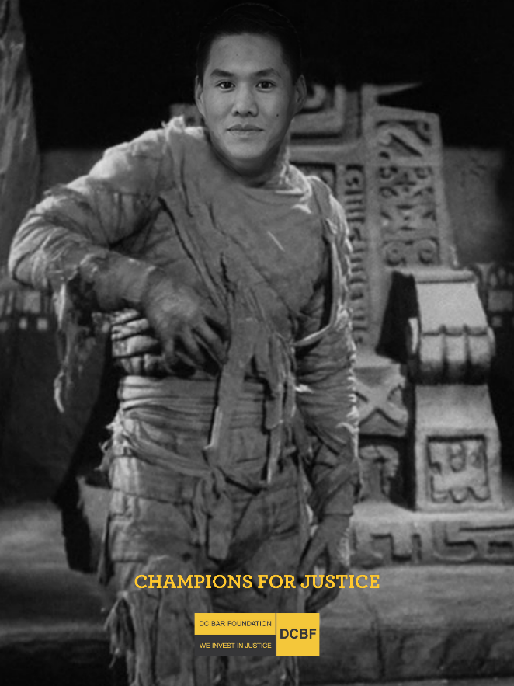
They say the Mummy’s Curse is "Death Shall Come on Swift Wings to Him Who Disturbs the Peace of the King." Not true. My curse is on the domestic abusers, the slumlords, the unfeeling bureaucrats, the bigots, and the schools that turn their backs on children with special needs. Theirs is a peace we should all want to disturb. It’s easy to get wrapped up in our own problems (I obviously do), but those problems are nothing compared to what so many of our neighbors in DC face every day.
Unfortunately, after a few thousand years in a sarcophagus, my curse skills have gotten a bit rusty. So, I’m relying on my colleagues at [INSERT FIRM NAME] to become Champions for Justice and raise funds for the DC Bar Foundation. The Foundation is the largest funder of civil legal aid in the District, who is working hard to transform DC’s legal aid network, working closely with all stakeholders, so that District residents have a fair and equal legal experience. The Foundation’s reach is as broad as the sands of the desert, reaching to over 30 legal service providers in just about every area of law for people who are financially disenfranchised or otherwise underserved in our city. And on top of that, the Foundation is at the forefront of DC’s civil legal aid network transformation, creating a civil legal experience where all District residents have a fair and equal legal experience, regardless of wealth, knowledge, or power.
So, click on [INSERT LINK HERE] to give on-line. It’s easy; I promise. And, if you want to get in the spirit (yes, pun intended), you can submit a picture of you in your favorite frightening Halloween-inspired costume or outfit to be entered into their end-of-October giveaway. Two lucky winners will each receive a $50 Uber Eats gift card at the end of October. A donation to DCBF, in addition to your entry, is highly encouraged. Submit your picture HERE. Help us reach our goal of [INSERT GOAL AMOUNT] and celebrate the Halloween season at the same time!
I’m in. Actually, I’m out, from under wraps and into the world again. And I can see it needs help. Please join me.
Subject line: Take a bite out of justice!
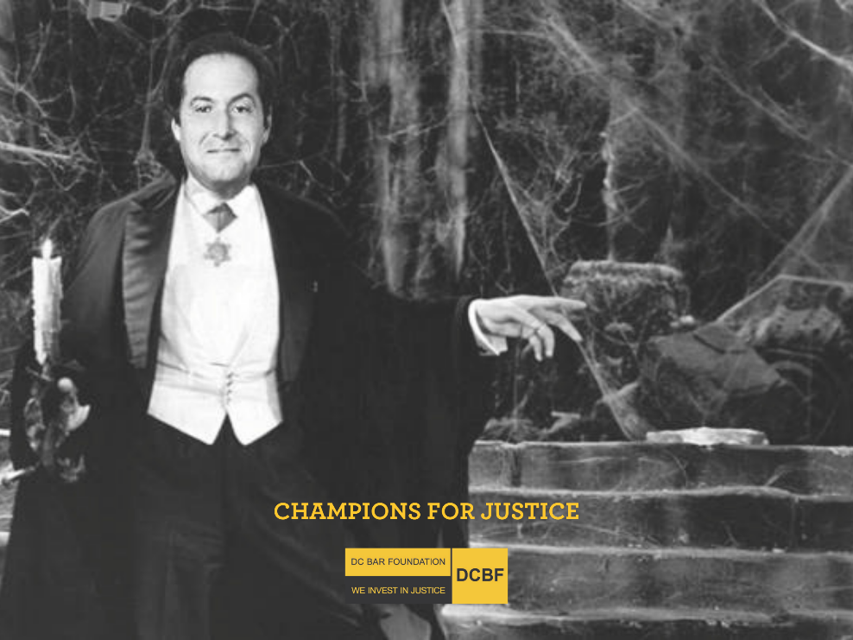
As [INSERT JOB TITLE HERE], I’m frequently up all night (sort of comes natural to me) worrying about how to close the justice gap. One group doing just that is Legal Counsel for the Elderly (LCE), a legal services organization right here in DC. LCE is terrific at meeting the legal needs of seniors with low incomes – one of the most vulnerable groups in our city. LCE does it all: securing government benefits like Medicaid, Social Security and Veterans benefits, fighting evictions, foreclosures and consumer fraud, preparing wills and powers of attorney, advocating for nursing home residents, and bringing their services to homebound folks who can’t go out to seek the services they need.
They depend largely on the DC Bar Foundation for support, which distributes the funds raised through Champions for Justice to LCE and more than 30 other legal services providers in DC. The Foundation actively works to transform DC’s legal aid network so that ALL District residents can have a fair and equal legal experience, regardless of wealth, knowledge, or power. I may be biased, but in my opinion, I think losing the Foundation’s support would drive a stake through the heart of so many of these legal services organizations’ operations. So, go online at [INSERT LINK HERE]. And, don’t forget to submit a picture of you in your favorite frightening Halloween-inspired costume or outfit to be entered into their end-of-the-month giveaway. Two lucky winners will each receive a $50 Uber Eats gift card at the end of October. Submit your picture HERE.
Don’t just lie around your castle waiting for nightfall. Give now. Fair warning: if you don’t donate, watch your neck.
I’m in. Can we Count on you?

Subject line: Cast a spell against injustice!
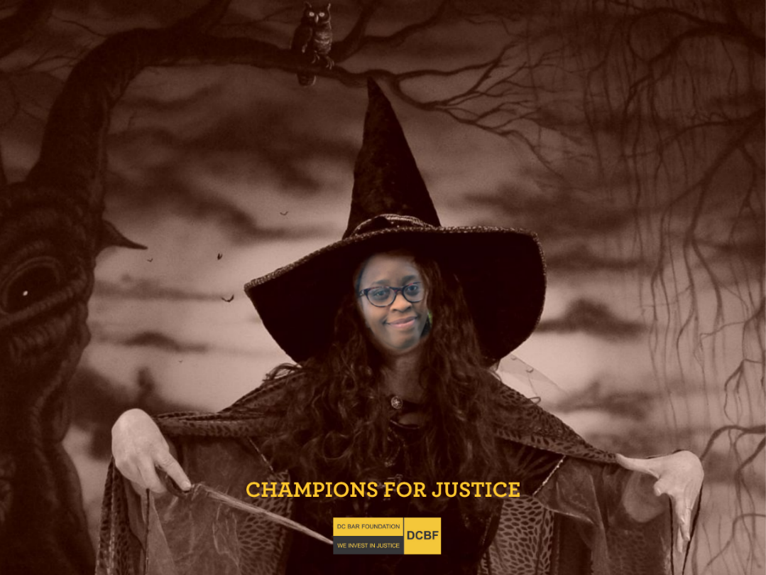
Double, double, toil and... oh forget it, I’m not Shakespeare. And I don’t want your eye of newt or toe of frog, either. I want your money.
More precisely, the DC Bar Foundation wants your money so it can distribute it strategically to more than 30 legal service providers in DC. Dp you want to know what’s really scary? A disconnected, un-coordinated civil legal aid network. Fortunately, the Foundation is actively leading the way in developing the District’s first-ever Coordinated Intake and Referral program for all areas of civil legal aid, bringing together legal services providers and other stakeholders across our city to make access to justice a reality for more residents than ever before.
Supporting the Foundation doesn’t require any spooky magic or dark incantations. It’s as easy as clicking on [INSERT LINK HERE]. Help [FIRM NAME] reach our goal of [INSERT GOAL AMOUNT] by making your gift today. And don’t forget that you can submit a picture of you in your favorite frightening Halloween-inspired costume or outfit to be entered into their end-of-the-month giveaway. Two lucky winners will each receive a $50 Uber Eats gift card at the end of October. Submit your picture HERE.
I encourage you to give to the Foundation through Champions for Justice so families can remain in their homes. So that children with special needs who are financially disenfranchised can get the dignified education they deserve. So that immigrants who survived torture in their homelands can have peace and stability. So that survivors of domestic violence can find safety and security, for themselves and their loved ones.
I have no magic to cast spells on slumlords. No potions to turn abusers humane. All I have is what you have: money that can be put to life-saving use through the DC Bar Foundation.
I’m in. Please give, or I’ll make you drink from my cauldron.
Subject line: Slay the dementors of debt!
He Who Must Not be Named has sent an army of Dementors in the form of student debt to feed off the despair and unhappiness of hopeful young wizarding lawyers. While those of us in house “Big Law” can usually escape the clutches of the Dementors of debt, other wizards are not so lucky. A first-year big law wizard makes around $190,000 while the average public interest wizard makes only $50,000. As a result, our friends in house “Public Interest” are often captured and hidden away for decades in a gruesome Azkaban prison fiercely guarded by the Dementors of debt.
I am asking you all to join me in donating to [FIRM NAME] Champions for Justice campaign in order to help fight off the Dementors of debt! This campaign raises funds for the DC Bar Foundation, the largest funder of civil legal aid in the District, who is working hard to transform DC’s legal aid network, working closely with all stakeholders, so that District residents have a fair and equal legal experience.
The DC Bar Foundation also critically provides debt relief to young legal services lawyers with staggering educational debts. These lawyers likely would not be able to support those most in need in our city if they had to also bear the full weight of their student loans. We have perhaps all felt the pressures of the Dementors of debt at some point in our wizarding lawyer lives, but some of our colleagues have felt their icy cold grip more intensely than others.
So, pull out your wands and donate today! And don’t forget to submit a picture of you in your favorite frightening Halloween-inspired costume or outfit to be entered into their end-of-the-month giveaway. Two lucky winners will each receive a $50 Uber Eats gift card at the end of October. Submit your picture HERE.
Will you join me? Expecto Patronum!

