Revised Request for Information (RFI)
Coordinated Intake & Referral Project
DC Bar Foundation

Updated December 23, 2021

Introduction
DCBF envisions a future where access to civil legal aid does not depend on prior knowledge of the civil legal system, power, or financial and other resources. We understand that to streamline legal services access for DC residents, we will have to increase coordination among the District's more than 50 civil legal aid providers.

Purpose and Scope
DCBF, in collaboration with the DC legal services community and other stakeholders, is developing a user-friendly, secure, accessible Coordinated Intake and Referral System (CIR) for residents of DC with civil legal needs. The CIR will serve as a single point of entry to easily connect residents with a civil legal services provider that can offer appropriate representation and/or legal resources and information. The system will leverage people and technology to handle intake, routing, and automated notifications to place cases with appropriate legal services organizations (LSOs). It will be integrated with a phone system and website that can be used by people seeking help as well as contact center software so that trained professional navigators can assist end users. DCBF will engage DC LSOs, other access to justice stakeholders, and client-eligible communities in designing and implementing this vital technology solution.

Here is a working version of a high-level CIR process flowchart:

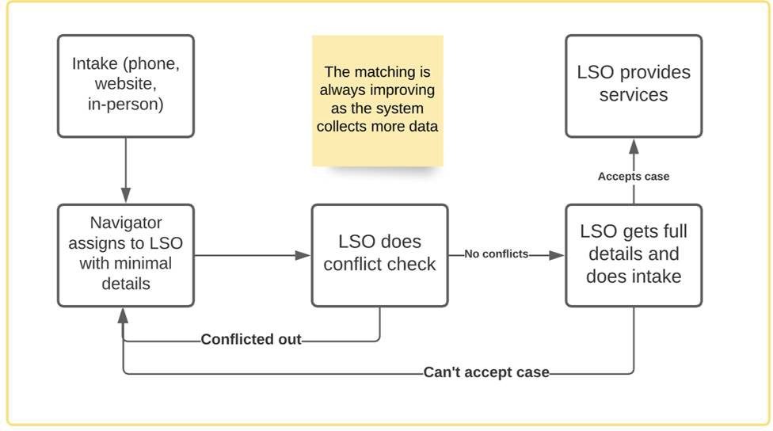

In order to establish the CIR program, we will need to gather a great deal of information about the existing civil legal aid network. We estimate that we will need two people to work closely with our system designer and the District’s legal aid organizations to understand the breadth and depth of the services that exist now. Though not exhaustive, we imagine these two individuals will perform the following activities, in partnership with the system designer:

- Gathering existing information on the services that each legal aid organization provides;
- Determining questions and clarifications about where cases should be routed;
- Meeting with legal aid organizations to discuss case placements;
- Drafting, revising, and finalizing a case placement logic document; and
- Developing and testing a pilot program to test case routing and placement.

We have budgeted approximately $150,000 to support this work.

Please note the following:
- All types of organizations (for-profit and non-profit) are welcome to submit an RFI response, including legal service organizations.
- Responding to this RFI is not a commitment to hosting the CIR once launched.
- This RFI is not soliciting input or interest from organizations to host the CIR program at this time.
- Submitting an RFI response is not a prerequisite to being considered for further CIR procurement or grant opportunities.

RFI Responses
Responses must be submitted via email to innovation@dcbarfoundation.org by February 15, 2022, by 5 p.m. Eastern Standard Time.

Organizations responding to this RFI must include:
- Organization name
- Primary contact name, title, email address, phone number
- A brief summary of your organization’s history, mission, and services

RFI Questions for Respondents
Please respond to the following elements:

- Capabilities. Describe your capabilities for assessing program needs and implementation of new wide-ranging projects that involve multiple stakeholders.
- Experience. Describe your experience with similar projects.
- Value-added products or services. Describe the potential for value-added products or services to meet the following success criteria:
  - Improve awareness and accessibility of legal services
  - Develop pathways to legal services by those who need them most
  - Reduce client bounce
  - Provide a trauma-informed solution
  - Complement legal services organizations’ existing intake procedures

- In-kind or donated products or services. Describe the potential for in-kind or donated products or services.

- Relevant experience and information. Describe any other relevant experience and information.

Questions About the RFI

Questions can be submitted via email to innovation@dcbarfoundation.org.

Disclaimers
This is a Request for Information (RFI) only and does not constitute a commitment, implied or otherwise, that the DC Bar Foundation (DCBF) will take procurement action in this matter. Further, DCBF is not responsible for any cost incurred in furnishing this information.

Any confidential information contained in an RFI response should be clearly marked “CONFIDENTIAL” within the document. Reasonable precautions will be taken to safeguard any part of the response identified by a respondent as being confidential.

